Issac Billow Code Review Lab 3
State Population
- I wasn’t able to open the database I got a error with will be below I took a screenshot
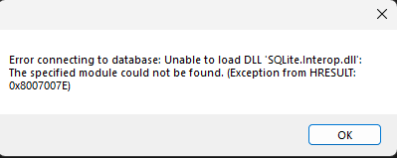

- Program couldn’t select a state to see the data for that because the database didn’t load
- Program couldn’t sort data because of no connection to the database
- Code very well organized! And easy to read!
- You have some comments. I would add more that just my opinion so the person who is reviewing the code can see what your doing instead of guessing/ easier to following along.
- Great state Repository class is awesome great job!
- Forms are well designed as well!

